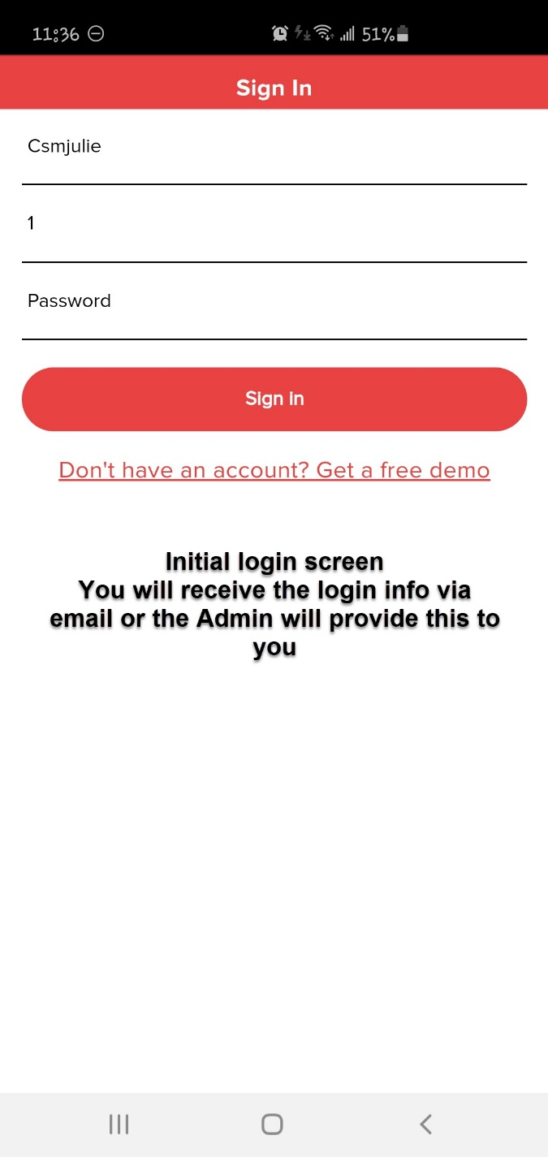 → → 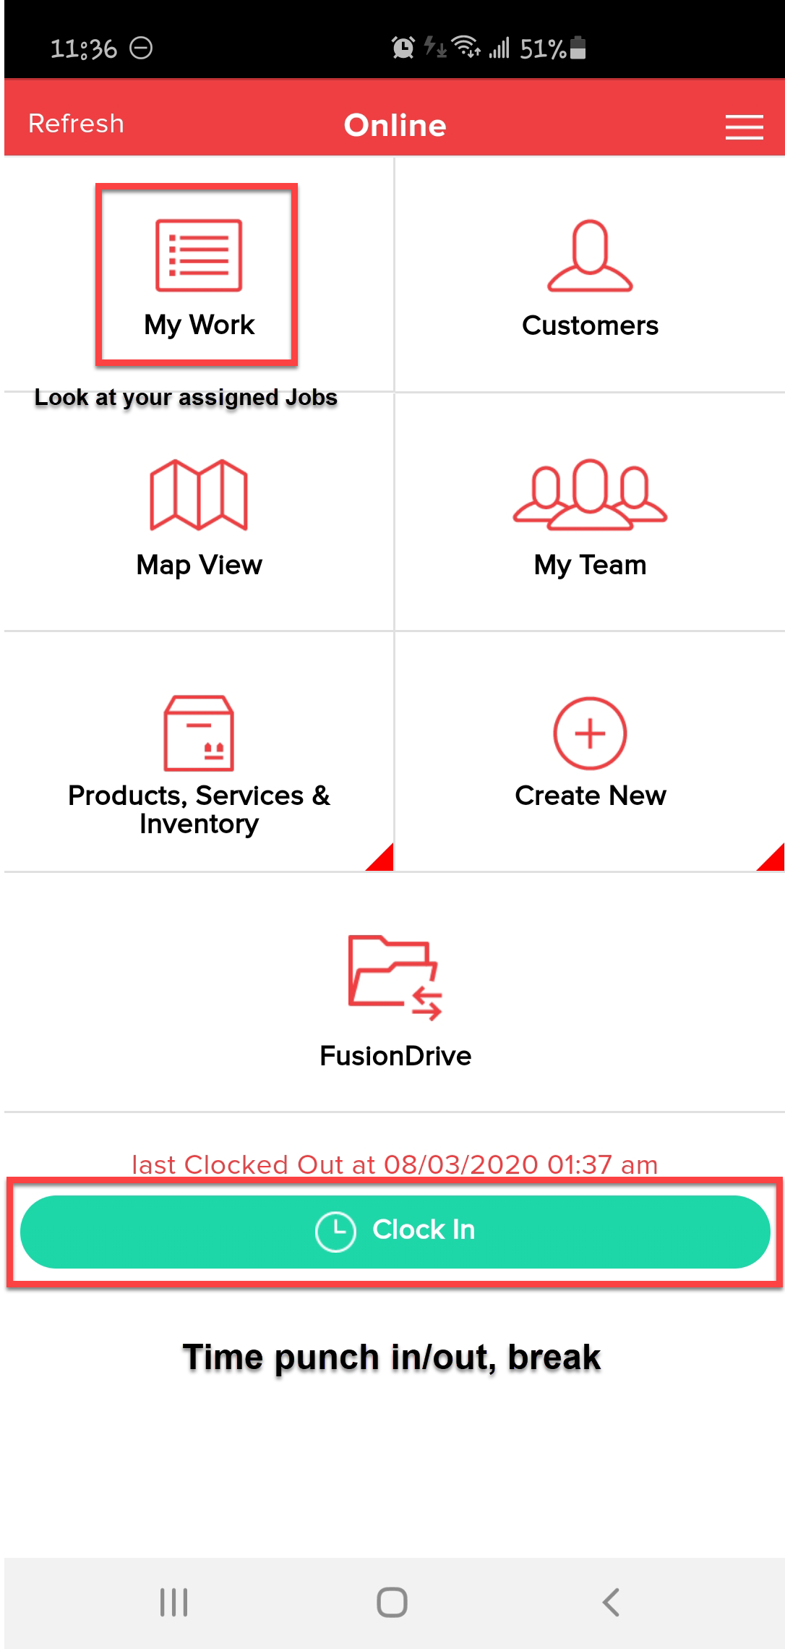

**Home Screen**

**My Work** – All jobs assigned to you; this defaults to the Current Day. You have the option to look at past jobs that were completed and incomplete jobs.

**Customers** – Permission based - This is the full customer list in Service Fusion, you can search by name, address, phone#.

**Map View** – Shows the map history of your jobs, you must scroll through each one.

**My Team** – View the pin drop location of another tech when they last interacted with the app (not real time GPS).

**Products, Services & Inventory** – View the company catalog for a quick price quote without having to create a job.

**Create New** – Permission based – Create a new estimate, job, or task from the app.

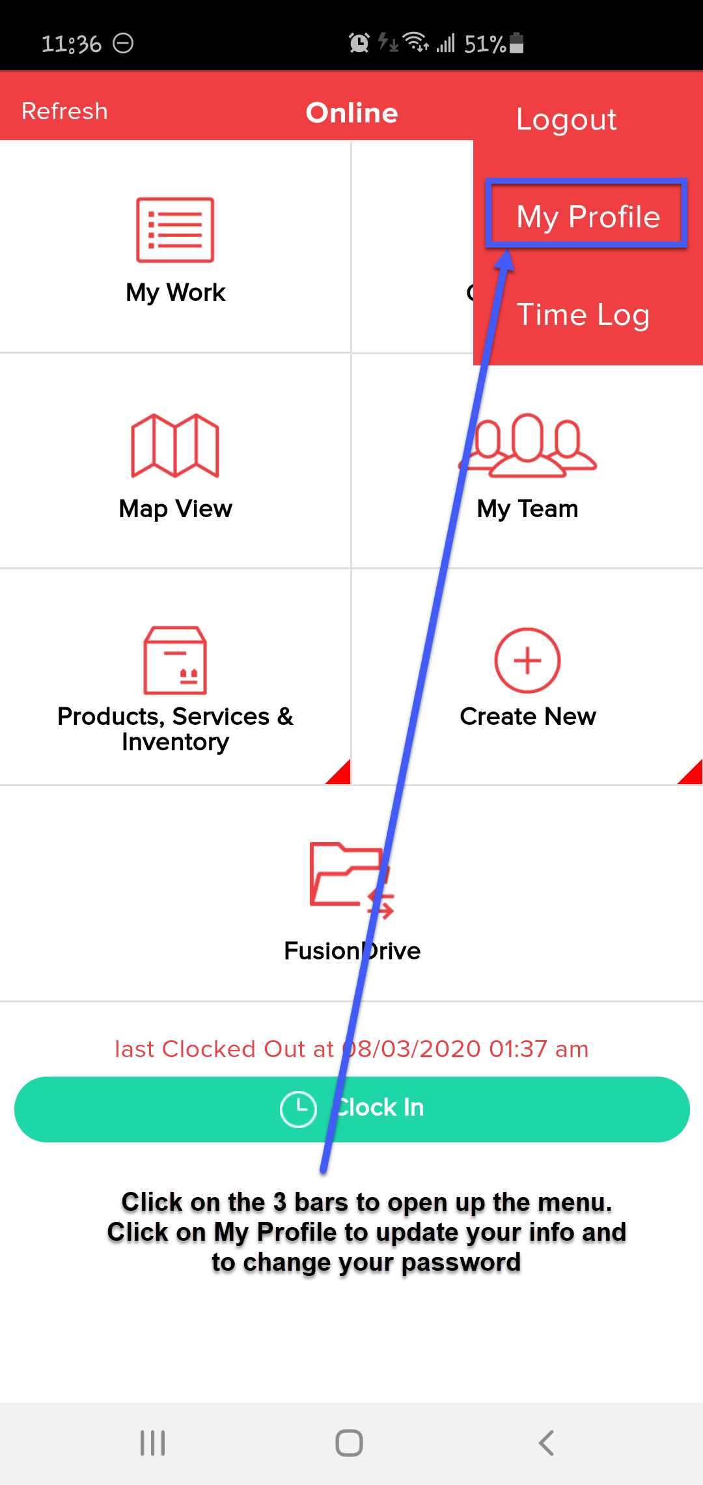 🡪🡪 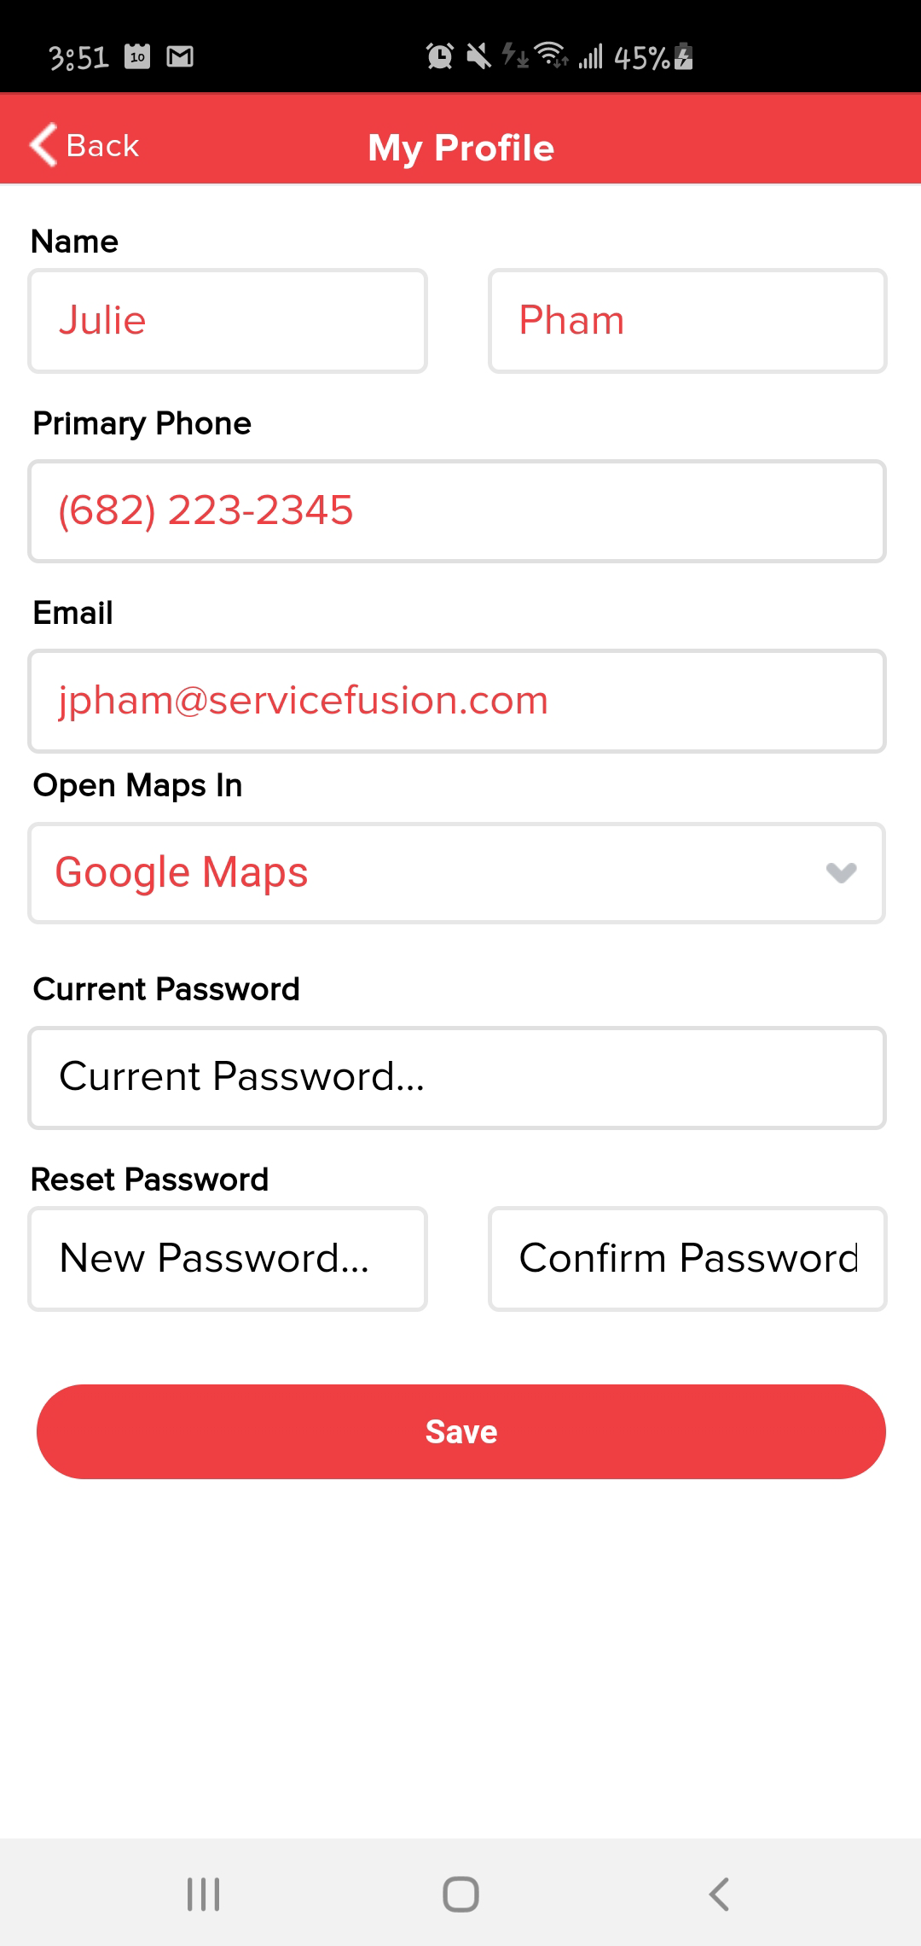

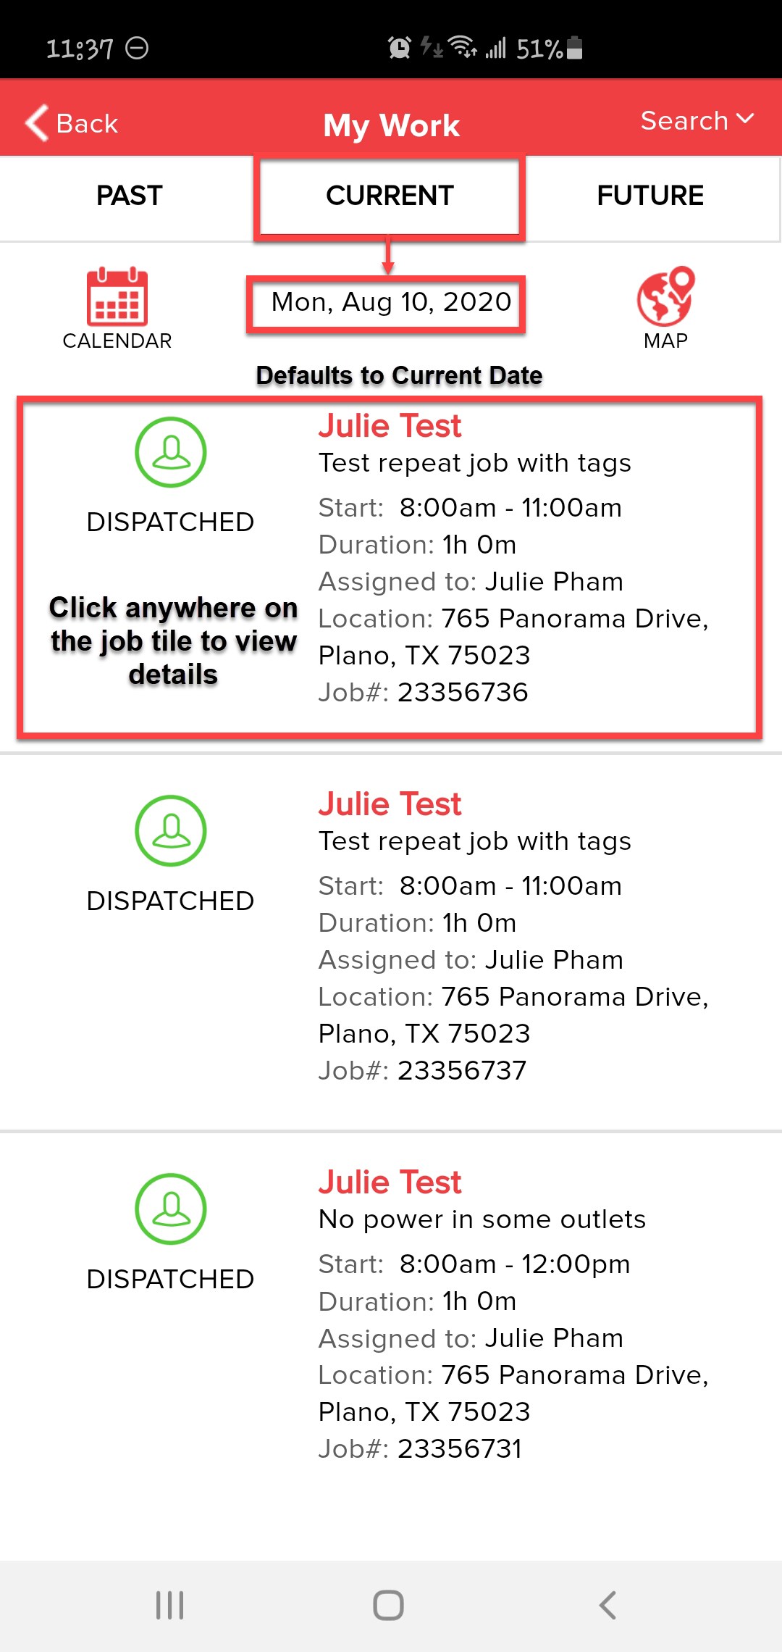 🡪 🡪 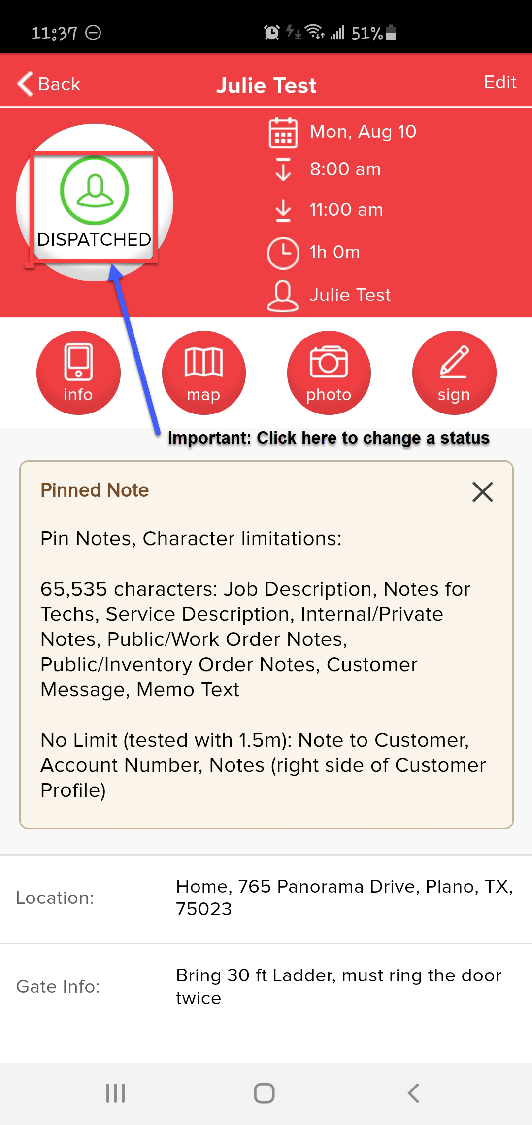

**Job Screen**

**Info – View the customer contact info, job history, and view past jobs with pictures attached.**

**Map – Driving directions to the job site, this will open your default app (Google Map, Apple, or Waze).**

**Photo – View pictures, Take new pictures, or Upload pictures from your mobile device (it is faster to take the pictures first and then upload them - 15 at a time) – no max on how many photos, but limited to 10 mb per picture.**

**Sign – Obtain customer Pre/Post signature for Before work is started or After work has been completed.**

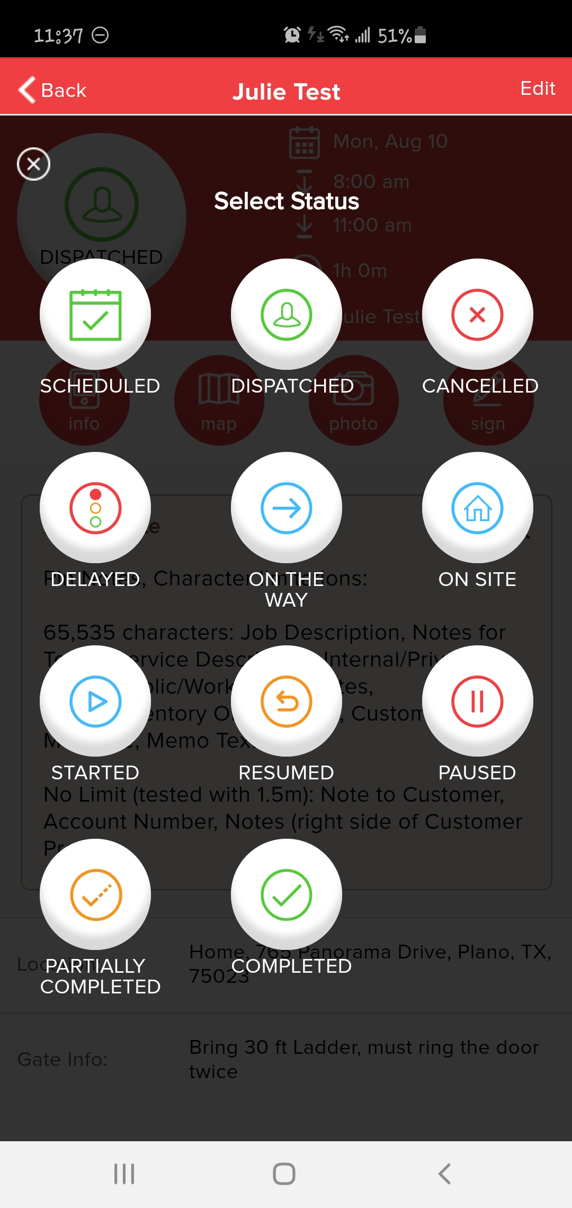

**Quick Status Overview**

Scheduled/Dispatched – This is assigned from the back office

Typical order of statuses:

1. On the way – triggers out the text message to the customer
2. On Site – Once you have reached the job site
3. Started – This automatically changes to Started when you hit “on-site”
4. Optional: Paused (break/lunch)
5. Optional if Paused: Resumed (coming back from break/lunch)

* You also need to go back to the main screen to clock out/break

1. Completed – Once you have added completion notes, added pictures (if applicable)

***Statuses are customizable, check with your Admin on your company workflow

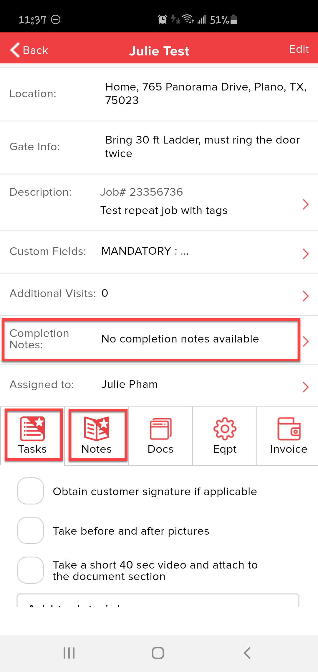

**Job Details**

Location: Address of job site

Gate Info: Access code/instructions for this location

Description: Details about the job, scope of work, info customer provided for this job (This prints on the Invoice)

Custom Fields: Additional data about the job (if applicable) (Option to add to invoice)

Completion Notes: Tech will fill this out, steps taken to complete the job, possible recommendations (This prints on the Invoice)

Tasks: Check list for techs

Notes: Contains additional info or instructions for the Tech

**You can also add additional private notes in this section between office and tech

Docs: the dispatcher can include any documents in this section for tech, or tech can add documents, also add Video (up to 40 secs each)

Eqpt: Customer equipment info, tech can pull up existing eqpt, or add from the field to customer profile (Option to add to invoice)

Invoice: Customer charges, add or adjust line items (if applicable)

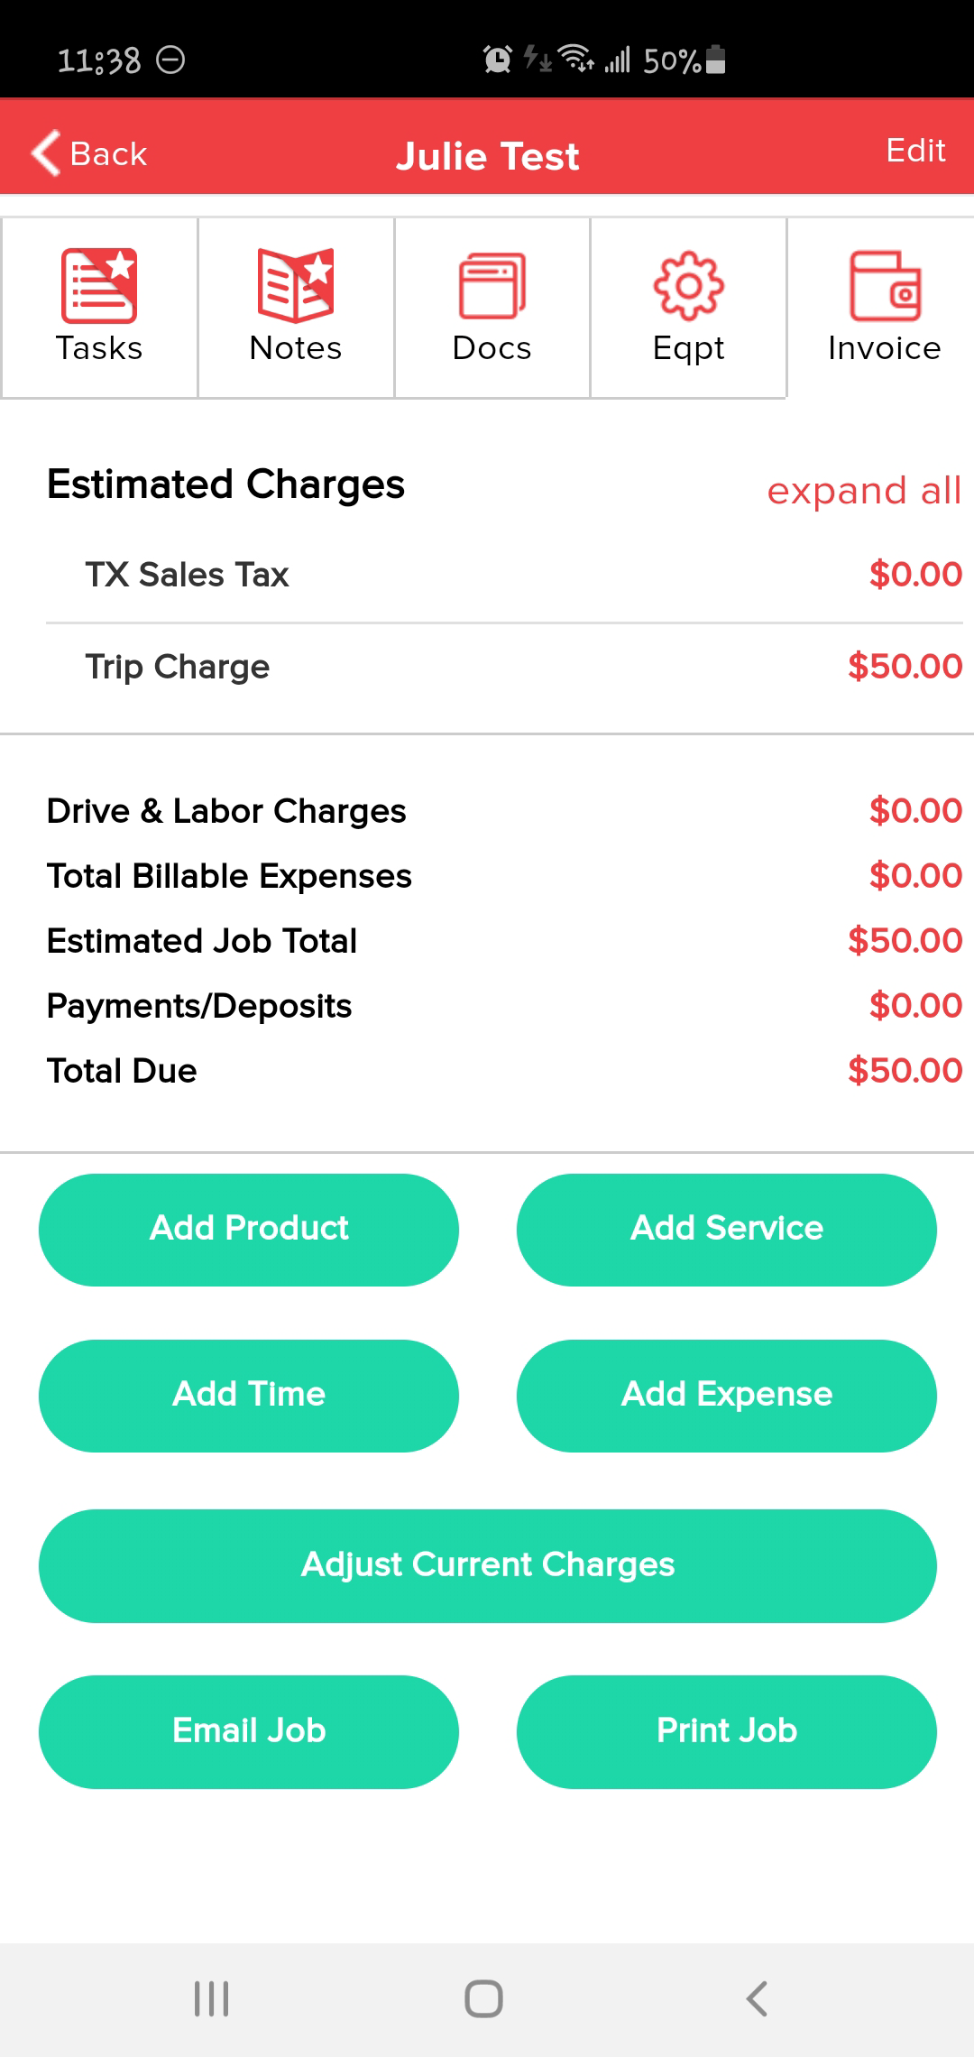

**Invoice Tab (Permission based access)**

**Add product** – Parts/Material related, possibly broken down by category and searchable at the top by name, description, part#.

**Add Service** – Labor/Install/Bundle prices possibly broken down by category and searchable at the top by name, description.

**Add Time** – Adjust Labor/Drive time on this job (permission based, check with Admin)

**Add Expense** – Typically for adding in additional supplies/contract labor, you can attach a picture of the receipt, option to bill the customer, or reimburse back to tech

**Adjust Current Charges** – Adjust the current charges, edit/remove a line item, also apply a discount in this area or add additional fees from list

**Email Job** – sends the job/work order to the customers’ email address (not a common process, **this is NOT the invoice, **also may contain info not relevant to the customer)

**\*\*IMPORTANT\*\***

Tech can adjust the job charges and notes as many times as needed if the job has not been invoiced.

Once the job has been finalized and an invoice number has been assigned, tech cannot adjust the job charges and will need to have the back-office update/correct this info.

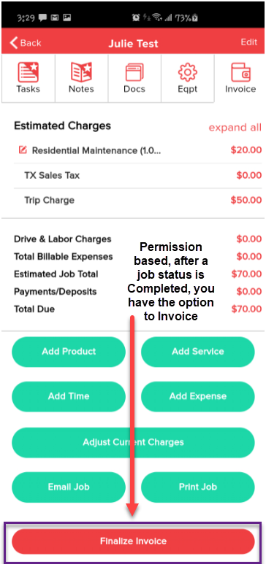

**Finalize Invoice** – Permission based, check with your Admin on the invoice process for your company.

This option only appears after you have marked a job as Completed.

**If there are **multiple techs** assigned to the same job, **ALL techs must mark the job as completed** before the “finalize invoice” option is available. Only 1 tech needs to create the invoice.

**\*\*IMPORTANT\*\***

Tech can adjust the job charges and notes as many times as needed if the job has not been invoiced.

Once the job has been finalized and an invoice number has been assigned, tech cannot adjust the job charges and will need to have the back-office update/correct this info.

.***PAYMENT GATEWAY MUST BE SET UP TO RECEIVE CREDIT CARD PAYMENT ON THE FIELD OR VIA CUSTOMER LINK**

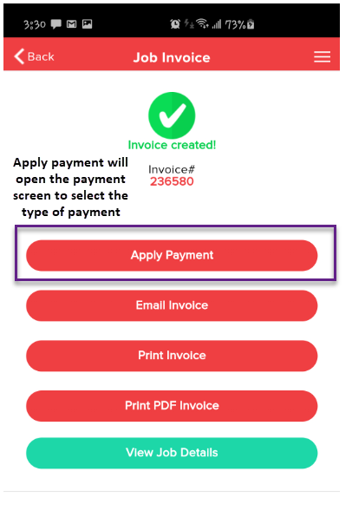🡪🡪 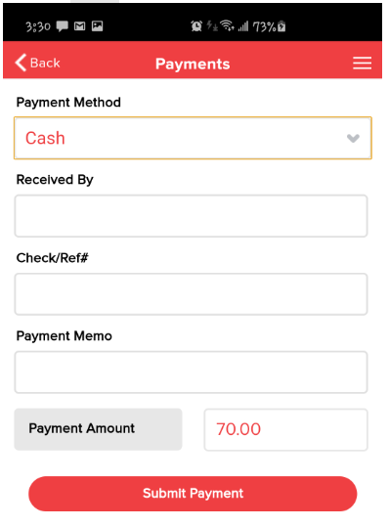

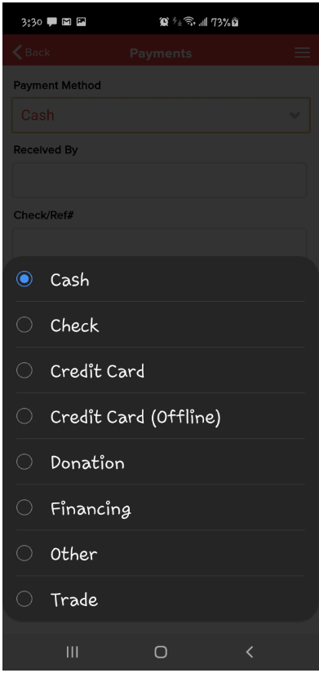 🡪🡪 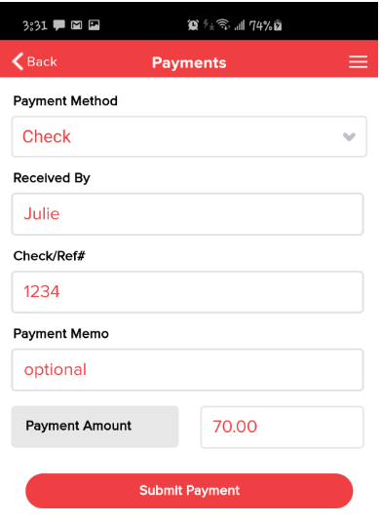

After payment has been submitted, the tech has the option to Email the invoice to the customer. If no payment is taken, the email option also includes a link for the customer to pay online by credit card if a payment gateway is setup.